**Task A**

**1. Discuss** the cloud technologies, architectures, and service models that are essential for effective hosting of Caveni Digital Solutions' Store Management System website.

To ensure that the location of the store management system of the company Caveni Digital Solutions Works well, we need to think about cloud technologies and services. The proposed store management system needs a robust and flexible hosting solution to efficiently manage resources and operational effectiveness. Cloud technologies such as infrastructure as a service (IaaS) and the platform as a service (PaaS) and software as a service (SaaS) Very important for this purpose (Ellman، 2018).

Provides us IaaS The basic things we need, like virtual machines, storage, and networking. This helps us to be flexible and scalable in website hosting. resembles Paas Platform that allows developers to build, deploy, and manage applications without dealing with complex infrastructure. SaaS It is when software applications are delivered over the Internet, so that users can access the system without worrying about hardware or software problems. (Ellman، 2018)

To host a store management system website, provides us with the use of IaaS Essential infrastructure parts for flexibility and scalability. Help Paas in website development and operation easily, while SaaS for specific software parts of the store management system, making it easier for people to manage product information (Ellman، 2018).

We also need to think about security. Another study talked about container security and how information can leak inside containers. Therefore, it is really important to ensure that the store management system website is secure and protects important product information. (Sultan، 2019).

There's also a study that talked about the impact of staying with a single vendor when using cloud services (Opara-Martins، 2016). This means that we need to be careful when choosing our cloud service provider to ensure that we are not stuck and can continue to use the hosting solution for the store management system website for a long time.

For a store management system website to work well, we need to understand cloud technologies, think about security, and be smart when choosing our cloud service provider. This way, we can make sure that the website manages resources well, works efficiently, and can grow as needed.

**Boost hosting productivity with infrastructure as a service (IaaS): IaaS is essential for providing essential resources such as virtual servers, storage, and networking. With this technology, resources can be flexibly configured and selected according to the requirements of the store management system, resulting in increased hosting efficiency and rapid responses to changes in demand.**

**Ease of use of PaaS development: PaaS provides developers with a tight and streamlined development environment, making it easy to build and deploy applications efficiently. With the help of this approach, Caveni Digital Solutions can reduce the time required to deal with technical issues and accelerate the creation of websites for store management systems.**

**Seamless delivery of SaaS-based applications: SaaS models simplify the use of software applications by eliminating the need to worry about infrastructure. This means that the Caveni Digital Solutions store management team does not need to deal with the subtleties of technical details in order to access the system.**

**Cloud data security: Security should be one of the most important concerns of your store management system. Technologies such as encryption and containers can be used to ensure data security in the cloud. Monitoring security concerns helps protect private data and ensures the system runs without problems.**

**Service continuity impact: Choosing a trustworthy cloud provider becomes even more important when considering service continuity. Staying with one vendor reduces the potential hassle of moving to a new service provider and ensures continuity of service.**

**Innovation and cutting-edge technology: Caveni Digital Solutions can employ big data analytics and artificial intelligence to optimize the operation of store management systems and provide customers with an enhanced shopping experience by leveraging cloud technologies.**

**Balance between cost and performance: When choosing cloud services, Caven Digital Solutions needs to take this into account. This can be achieved by closely examining operational requirements and assessing expenses in order to determine the best possible solution.**

**Keep up with technological developments: Caveni Digital Solutions can keep up with the latest technological developments by adopting cloud technologies. Over time, these technologies can be used to bring additional features to consumers and continuously improve performance.**

**Caveni Digital Solutions can create an innovative store management website that is efficient and easy to use, meets organizational goals and delivers an exceptional user experience through the full use of cloud technologies and service models.**

**2. Discuss the** importance of n-tier in designing and building a website for the organizational needs of Caveni Digital Solutions' store management system. How does it strengthen the structure of the public system?

The importance of architecture lies at the level n In the context of designing and building a website for a company's store management system Caveni Digital Solutions In its ability to enhance the overall system architecture by providing modularity, scalability and maintainability. Divides layer structure N, also known as multi-layer architecture, the entire system into multiple layers, each of which is responsible for specific functions, thus promoting a more structured and efficient system design (Tafti, 2012).

The three main levels in the structure n-tier They are the display layer, the application layer, and the data layer. The presentation layer, also known as the UI layer, is responsible for presenting information to users and collecting user input. The application layer, also known as the business logic layer, contains application logic and acts as an intermediary between presentation layers and data. The data layer, also known as the storage layer, is responsible for managing data storage and retrieval. (Senthil, 2007)

**In the context of a store management system, the structure of the N layer can be reflected in the system as follows:**

**Presentation layer:** This layer can host the user interface to efficiently manage product information, providing an intuitive and easy-to-use interface for adding, editing, and accessing product information. It can also facilitate powerful search functionality and advanced filtering options for retrieving product information.

**Application layer:** Business logic to manage various product attributes such as size, color, and weight can be included in this layer. It can also handle the processing of user requests and interactions, ensuring seamless communication between presentation and data layers.

**Data layer:** This layer can manage the storage and retrieval of product information, ensuring real-time updates and data accessibility.

The benefits of this architecture for a store management system include improved maintainability – where modifications can be made to a particular layer without affecting the entire system, and enhanced scalability, where each layer can be scaled independently to accommodate changes in demand. Allow modularity of layer structure n Easier troubleshooting and debugging, contributing to overall system reliability and robustness (Tafti, 2012).

The adoption of the n-tier structure for the store management system site is in line with the organizational needs of Caveni Digital Solutions by providing a structured, modular and scalable system design that enhances resource management, operational efficiency, and an overall shopping experience.

**Integration of layer N architecture with the needs of Caveni Digital Solutions:**

**Improved maintainability**

By breaking down the system into multiple layers, developers can efficiently perform modifications and maintenance procedures. Each layer can be updated individually without affecting the other parts which contributes to reducing problems and speeding up maintenance.

**Expansion Ability:**

The N-layer structure can easily adapt to the expansion of the company's business. Thanks to its flexible architecture, additional layers can be added or expanded to keep pace with business growth and increase data volume.

**Seamless interaction between display and data:**

The application layer acts as a bridge between the display layer and the data layer, ensuring seamless communication between all parts of the system. This interaction improves system performance and contributes to improving the user experience.

**Effective data management:**

At the data layer, information can be organized and managed effectively, contributing to a flexible and accessible database. Search and query performance can be improved to ensure fast and reliable response.

**Facilitate integration with new technologies:**

N-level architecture provides easy integration with new technologies, such as artificial intelligence or advanced data analytics. Additional layers can be added to accommodate more technology and innovation.

**Improve the end-user experience:**

Thanks to the simple user interface in the presentation layer, and effective interaction with the application layer, an improved user experience can be achieved. The interface can be customized to better meet users' expectations and needs.

In this way, the N-layer architecture demonstrates its effectiveness in enhancing the organizational capabilities of Caveni Digital Solutions' store management system, contributing to improved overall system performance and efficiency.

3. Study and negotiate the impact of hosting the proposed store management system in the cloud, focusing on functionality improvements and effective system management. How does cloud hosting affect the overall performance and maintenance of the system?

Offering hosting the proposed store management system (SMS) in the cloud has significant improvements in functionality and effective system management. The adoption of automated computing allows for self-management and self-improvement of the system, leading to improved resource management and scalability. This ensures that the system of SMS Dynamically adapt to changes in requests, improving its performance and resource utilization. (Senthil، 2007)

Introducing an effective system management system via economic multi-cloud data, contributing to effective system management by providing high availability and reliability of the system SMS. This approach ensures that the system can manage its resources efficiently across multiple cloud environments, enhancing error tolerance and system resilience. (Zhang، 2015)

The certification concept of cloud service dependency, as I explored, is crucial for effective system management in the cloud. By verifying and ensuring the integrity of cloud services on which the system relies (Ruan، 2017)SMS, the system can maintain its functions and performance, contributing to the effective management of the system.

Cloud hosting also affects overall performance and system maintenance. An efficient multicloud data management system not only enhances system management, but also contributes to overall system performance by providing high availability and reliability. The system ensures consistent and reliable performance to meet the requirements of the commercial organization and its customers. (Zhang، 2015)

Cloud hosting for the proposed SMS system brings functionality improvements through automated computing, economical multi-cloud data system, and certification to cloud service dependency. These aspects contribute to effective system management, guaranteed resource management, scalability and high availability. Moreover, the overall performance and maintenance of the SMS system is positively affected by the reliability and fault tolerance provided by the cloud hosting environment.

**Here in the form of points that can clarify the answer further:**

The transition to store management system cloud hosting is a fundamental advance towards improving system performance and facilitating maintenance. Let's explore this improvement through several aspects:

**Improvements in functionality:**

**1. Scalability:**

With the ability to handle diverse workloads, cloud hosting enables the system to adapt to changes in demand effectively. The system can grow automatically to meet growing needs without affecting its performance.

**2. Availability and Accessibility:**

Access to the system from anywhere connected to the Internet provides facilitation of real-time updates and remote information management, ensuring continuity of access for certified employees.

**3. Reliability and repeatability:**

Providing reliable infrastructure with redundancy by cloud service providers reduces system downtime due to maintenance or malfunctions, enhancing its continuity and efficiency.

**4. Advanced Services Integration:**

Deliver cloud platforms that provide integrated services, including security and analytics, that can be effectively used to improve security, analyze sales trends, and manage the product.

**Effective system management:**

**1. Cost effectiveness:**

Pay-as-you-go cloud hosting models allow integration with the actual resources used, optimizing cost, and especially convenient for retail businesses with changing requirements.

**2. Automatic updates and maintenance:**

Offering cloud service providers for patching, security updates, and infrastructure maintenance eases the burden of internal IT teams, allowing them to focus on system improvements rather than routine maintenance.

**3. Improve disaster recovery:**

Delivering integrated disaster recovery systems that reduce data loss and reduce system downtime by ensuring faster data backups and recoveries in emergency situations.

**Impact on overall performance and maintenance:**

**1. Performance:**

Enhanced system performance comes through scalability and efficient resource allocation in cloud hosting, which maintains responsiveness even at peak times, enhancing the shopping experience.

**2. Maintenance:**

Facilitate system maintenance by delegating device management tasks and security updates to service providers that enable the internal team to focus on system optimization without devoting itself to routine maintenance.

The use of cloud hosting for the store management system embodies an overall improvement, simplifying management and significantly enhancing performance, by offering a range of tangible interactions and benefits.

4. Evaluate different cloud technologies and service models in the context of store management system hosting. How do these technologies align with the specific needs of Caveni Digital Solutions' store management system, and what benefits do they offer?

**Based on previous research, let's evaluate the most suitable option for Caveni Digital Solutions' Shop Management System (SMS):**

**1. Automatic computing and self-optimization:**

- **Advantages:** Enable self-management and self-improvement of the system, which enhances resource management and scaling.

- **Considerations:** Ensure that an automated computing solution meets specific SMS requirements and contributes to improved operational efficiency.

**2. Economic Multicloud Data Hosting:**

- **Benefits:** High availability and reliability, and efficient resource management across multiple cloud environments, enhancing fault tolerance and system resilience.

- **Considerations:** Assess financial implications and ensure compatibility with the functions and performance of SMS.

**3. Certify cloud service dependency:**

**- Benefits:** Verification and ensuring the integrity of cloud services on which the system depends contributes to effective system management.

**- Considerations:** Implement robust security measures to protect against potential risks and ensure the continuity of SMS functionality.

Based on these options, a hybrid approach is proposed as the most appropriate option. This approach combines automated computing for self-optimization, multicloud data hosting for flexibility, and cloud service dependency certification for enhanced security. This trend aims to exploit the mutual benefits of each solution, creating a robust, secure and adaptable hosting environment to the needs and challenges of the store management system.

In this context, when looking at cloud technologies and new service models, the suggestions can be supplemented as follows:

**Cloud Service Models:**

**Infrastructure as a Service:**

Benefits:

Offering full control over system configuration is key to getting the most out of the cloud. This model allows for advanced infrastructure customization, contributing to excellent performance and efficient integration with SMS requirements. Full configuration flexibility opens up a horizon for continuous improvements and advanced integration.

Considerations:

These solutions require a careful assessment of the requirements of the store management system and ensure that the infrastructure complies with those requirements. Needs must be carefully identified to ensure that this model meets the unique SMS requirements

**Platform as a Service:**

Benefits:

Using the model "Platform as a Service" is an impressive option for accelerating the development and deployment of applications. Simple management reduces the complexity of operations and increases deployment efficiency, improving time-to-market and reducing costs.

Considerations:

The compatibility of the system's functionality with the "Platform as a Service" model should be determined and its efficiency in performance measured. This model may be suitable for environments where some customizability is sacrificed for simplicity and speed.

**Software as a Service:**

Benefits:

Using SaaS is an effective solution to provide ready-to-use solutions over the Internet. This saves development time and accelerates integrations, while providing an instantly accessible solution.

Considerations:

This model requires effective integration with the store management system to ensure seamless integration. It should be assessed for its suitability to unique business requirements.

**Advantages and compatibility:**

**Scalability:**

The hybrid approach stands out as examples of achieving sustainable scalability. Resources can be scaled flexibly to meet growing performance needs without sacrificing total control.

**Resource Management:**

The hybrid approach shows an effective balance between full control of resources and the ability to respond quickly, contributing to improved store management

**Cost Effectiveness:**

The use of software as a service offers an opportunity to improve cost-effectiveness by reducing costs and time spent on development

**Flexibility:**

Enabling infrastructure configuration as needed enhances flexibility, allowing the system to be easily adapted to future variables and developments.

**Security considerations:**

A vital element of each model is the guarantee of security. Strong security measures must be adopted, encryption ensured, and potential security challenges addressed in every aspect.

**Seamless integration:**

The effectiveness of a store management system comes from the good integration of its components. Seamless integration with the chosen model must be ensured to get the most out of the cloud.

**Future Technology:**

The ability of the system to keep pace with future technology and its easy integration must be considered. This avoids large substitutions in the future and maintains sustainable updates.

**Flexibility and customization:**

A hybrid approach is considered a better menu for a perfect balance between flexibility and customization. Allows allowing custom configuration with the ability to integrate with ready-to-use solutions.

**Sustainability and continuous improvement:**

Striking a balance between immediate performance and the ability to evolve leads to the sustainability of the system and the possibility of continuous improvement by keeping pace with developments and changes in business needs.

By choosing a hybrid approach that integrates automated computing, multicloud data hosting, and cloud service dependency certification, Caveni Digital Solutions can effectively and sustainably improve its store management, while providing high performance and seamless integration.

**Task B**

**5**. Formulate a multi-page website based on the user's requirements for what is mentioned in the scenario.

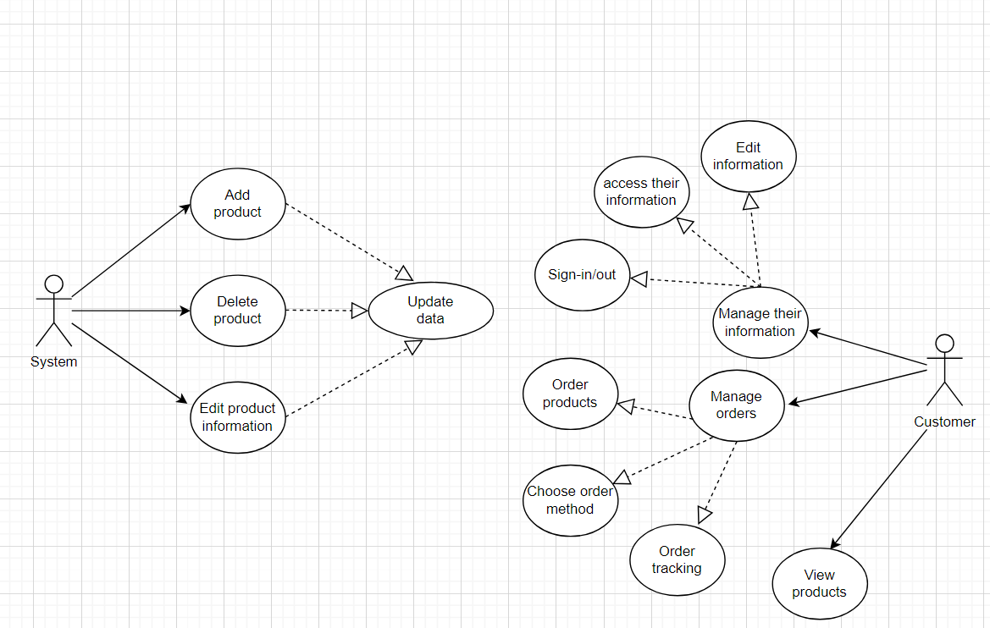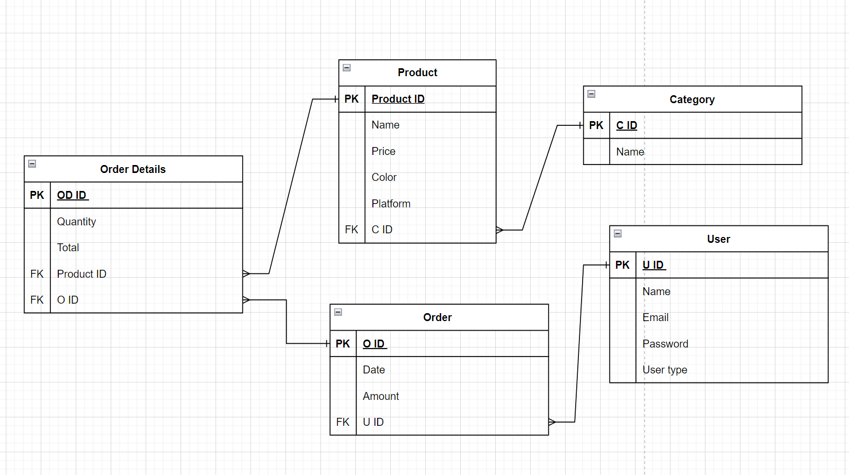

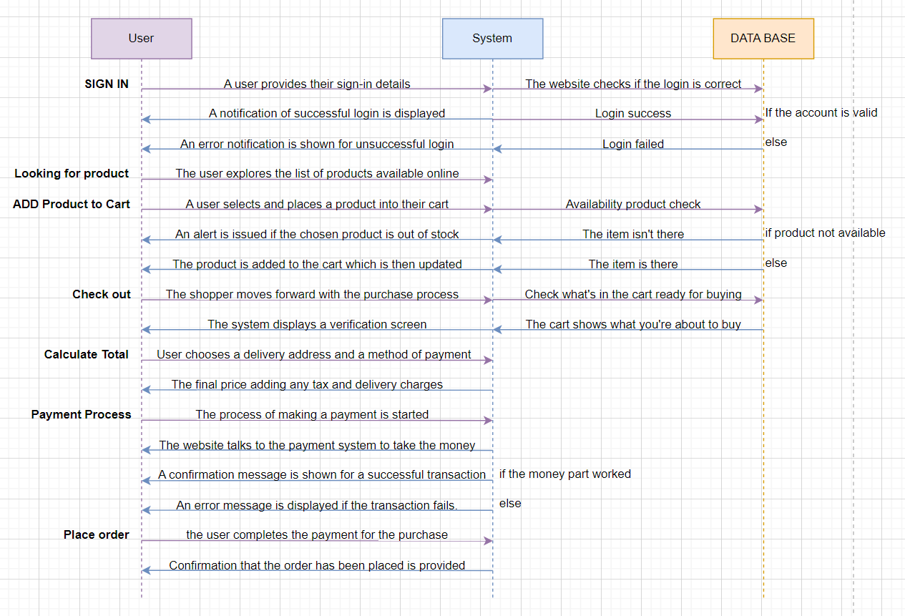

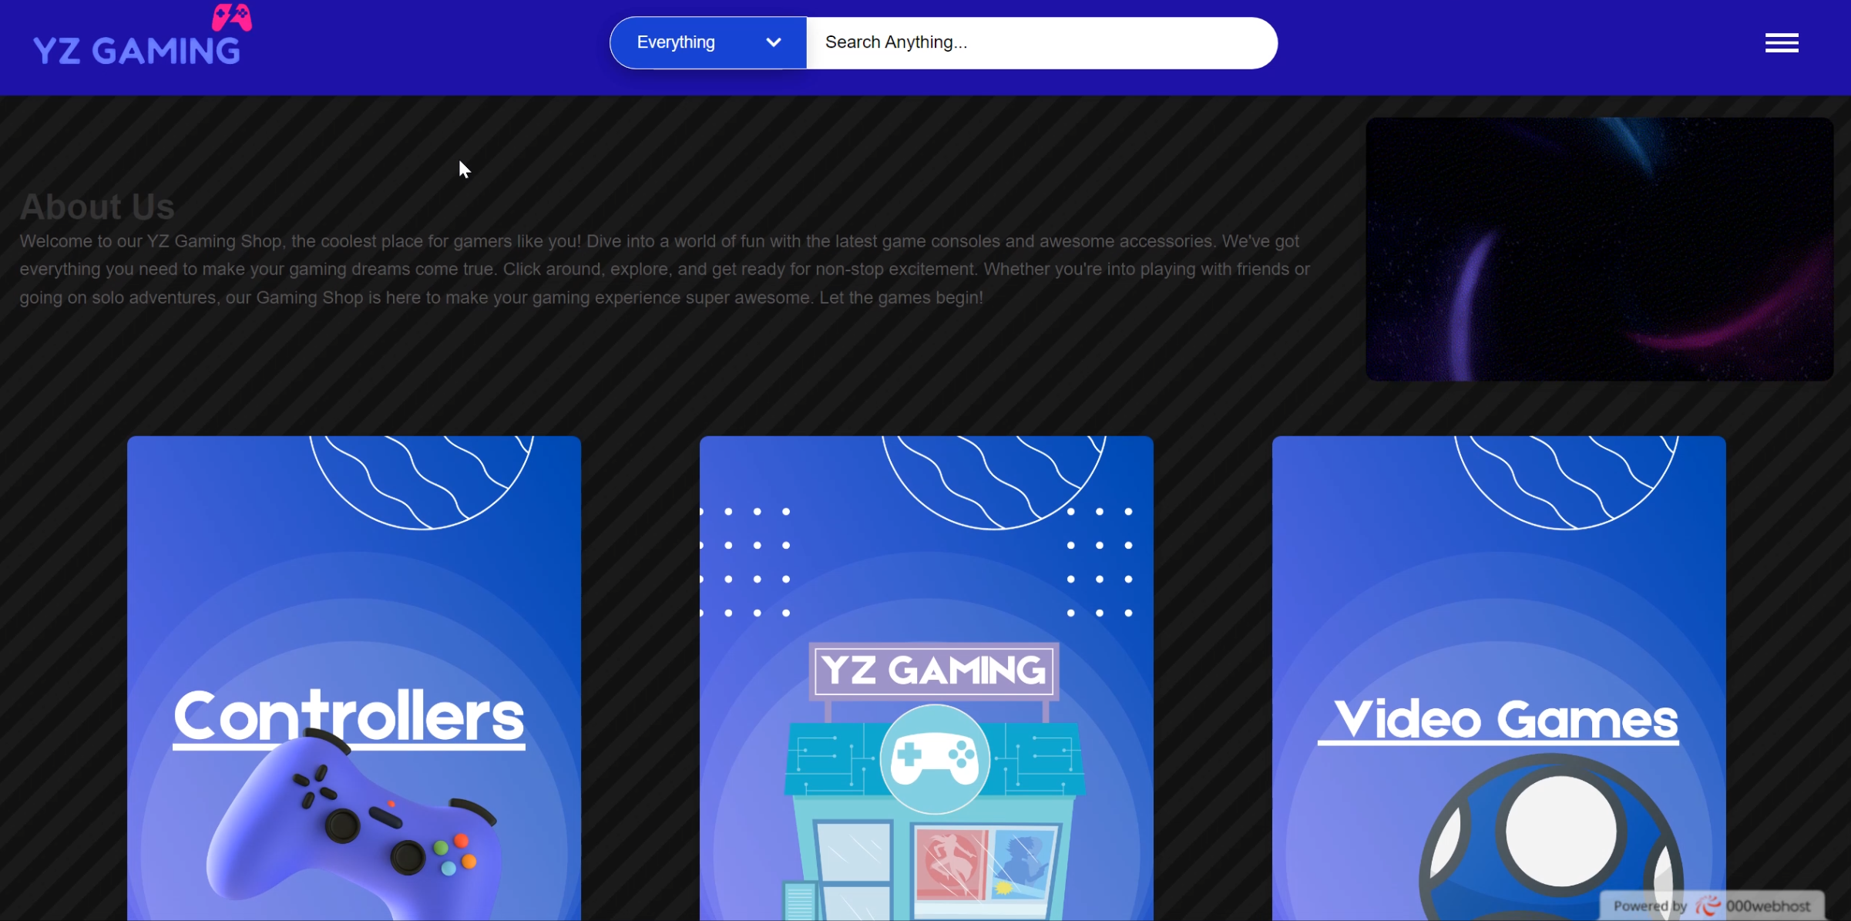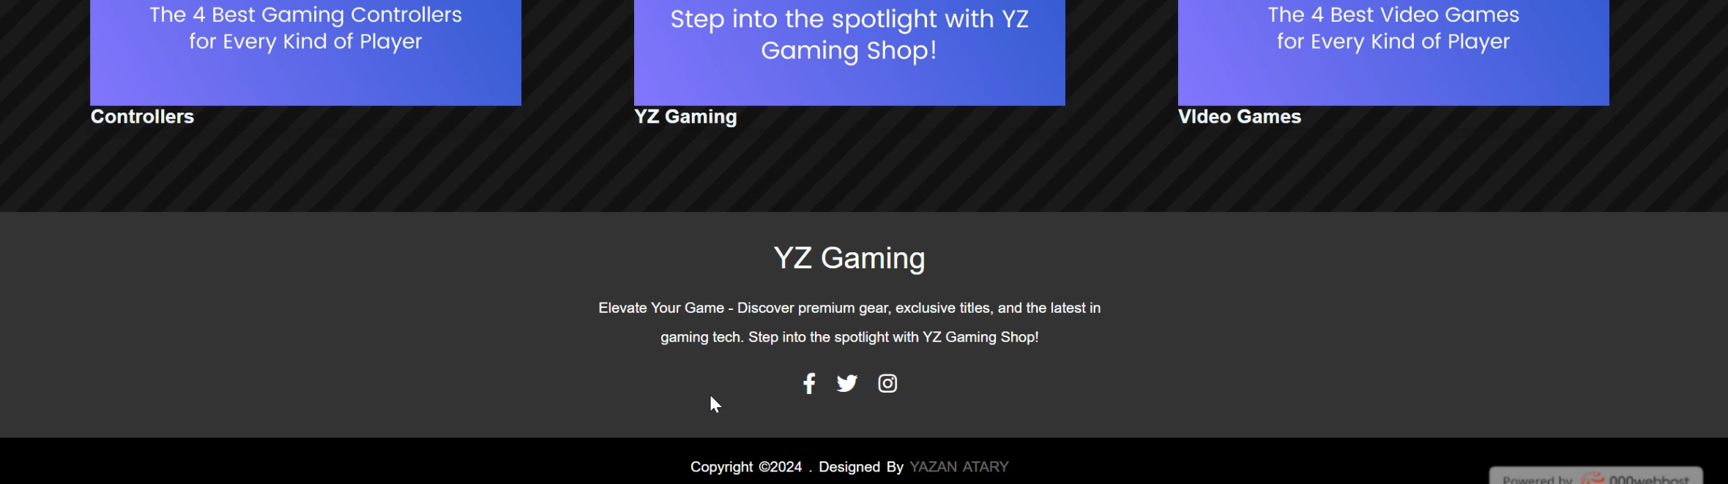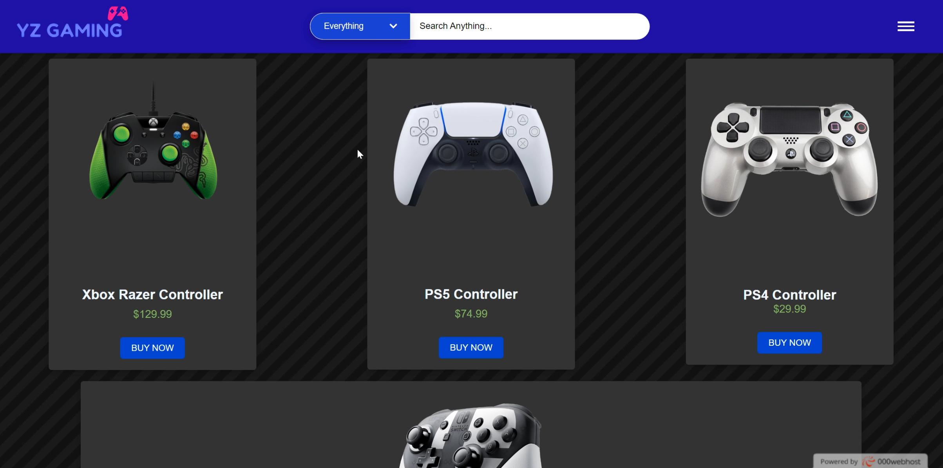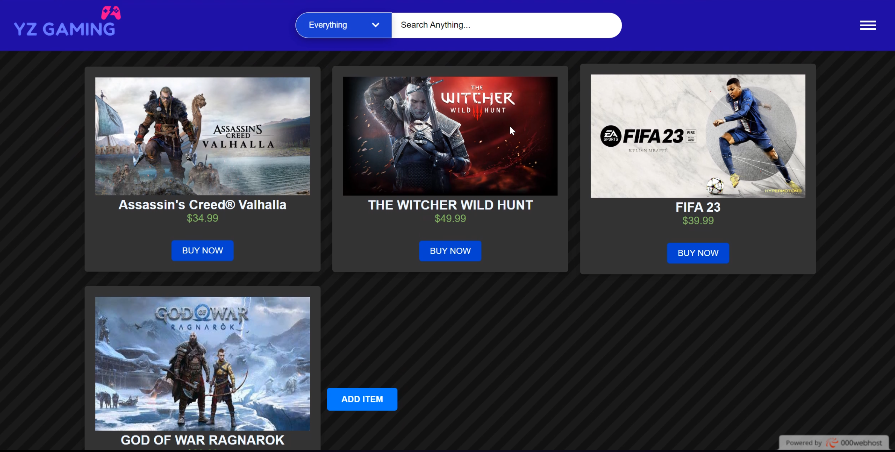

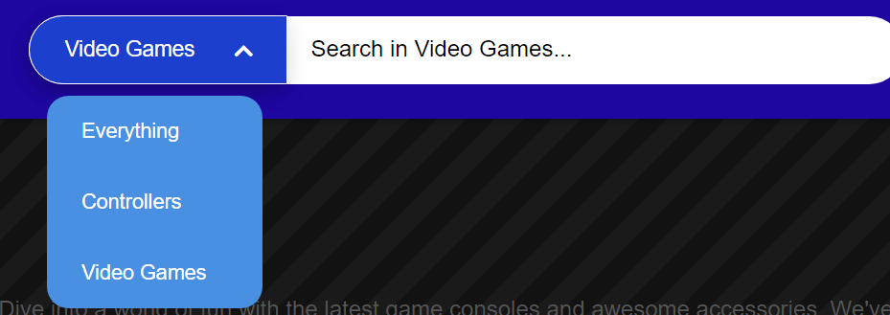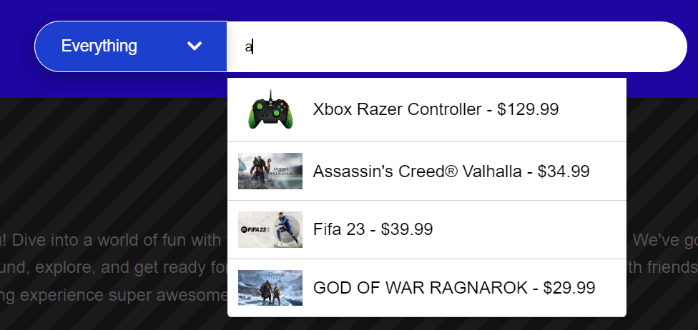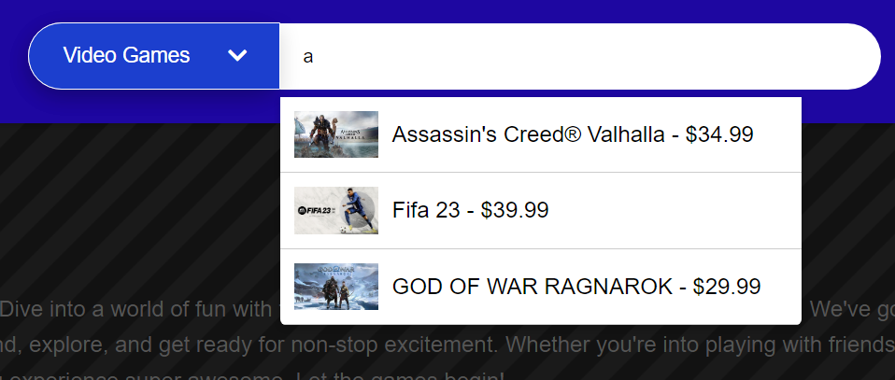

**6**. Discuss the differences between online website builders and tailor-made websites by considering design flexibility, performance, functionality, user experience (UX), and user interface (UI). Evaluate the tools and techniques available to design the web application contained in the scenario.

Discuss the differences between online website builders and specially designed websites:

In the world of web development, there are significant differences between online website builders and specially designed websites. These differences include aspects such as design flexibility, performance, functionality, user experience (UX), and user interface (UI). We will focus on evaluating each aspect and how it affects the choice of tools and techniques for web application design in the YZ Gaming scenario.

Design flexibility:

Online Creation Tools:

Offering templates that are easy to customize but limited.

Beginners can quickly create sites thanks to simple interfaces.

Specially designed websites:

Enable the design team to have full control over all aspects of the design.

The ability to improve the experience accurately to meet the needs of the user.

Performance:

Online Creation Tools:

Good performance for SMEs.

You may experience performance constraints with large projects.

Specially designed websites:

Provide accurate performance improvements using the latest technology.

Possibility to improve download speed and site responsiveness.

Functions:

Online Creation Tools:

Offer ready-to-use and easy-to-use functionality.

Functionality can be limited compared to custom design.

Specially designed websites:

Provide a unique experience thanks to functions customized to the customer's needs.

The possibility of integrating complex and unique functions on site.

User Experience (UX):

Online Creation Tools:

Deliver simple and easy user experiences.

Options for UX optimization may be limited.

Specially designed websites:

Carefully define the user experience to ensure effective and enjoyable interaction.

The ability to customize the journey for each user and meet their expectations.

User Interface (UI):

Online Creation Tools:

Limitedly customizable ready-made interfaces.

Options for UI design may be limited.

Specially designed websites:

Fully customized UI design for corporate identity realization.

Focus on making the user interface attractive and easy to use.

Evaluation of tools and techniques:

Usage:

Online builder tools have been selected for quick creation and easy integration.

It allows fast site construction at low cost.

Effectiveness:

Achieve good performance for simple and average website.

Take advantage of out-of-the-box features to meet the needs of the scenario.

Flexibility:

Provide limited flexibility in customization.

Fast integration and easy construction of small projects.

Control:

It allows full control over the design and performance of the site.

Possibility of optimizing the code and technology as needed.

Cost:

Suitable for projects with a limited budget.

A custom design provides value for money.

Conclusion:

Online builders for the YZ Gaming site were chosen due to the need for a simple site structure and fast integration. This enables a quick presence on the Internet and effectively achieves the planned purpose.

7. Create a comprehensive design for a fully functional website, analyzing potential challenges and constraints that may arise during the development process.

**Comprehensive design of the YZ GAMING website for selling gaming products:**

**Front End Design:**

**UI/UX:**

Responsive interface design to provide a seamless user experience across all devices.

Use attractive and high-quality visuals to display gaming products in an attractive and exciting way.

**Navigation and Information Engineering:**

Effectively organize products into categories and subcategories for easy access.

A simple and intuitive navigation system that helps users quickly find the products they are looking for.

**User-friendly interface:**

Added the ability for users to add their own products to the site, with an automated update of the database.

Provide an easy editing interface for editing and deleting products.

**Backward Development:**

**Database Design:**

Build an effective database to efficiently manage products, accounts and orders.

Real-time updates between the administration interface and the site for instant product updates.

**User authentication:**

Implement secure authentication mechanisms to manage user accounts and secure personal information.

**Search and filter function:**

Adding a powerful and powerful search feature that makes it easier for users to find products quickly.

Design filter tools to improve your browsing experience and find products.

**Administration Panel:**

Create an easy-to-use management dashboard to efficiently manage products, orders, and customer data.

Provide detailed reports and statistics to assist in strategic decision-making.

**Potential challenges and limitations:**

**Data consistency:**

Ensure effective synchronization of data between the management interface and the site to avoid any discrepancies.

**Improved performance:**

Improved performance to ensure a seamless user experience even with large inventory and complex search functions.

**Security concerns:**

Integrate robust security measures to protect sensitive information and secure the site from cyber threats.

**Scalability:**

Planning to scale up infrastructure to keep pace with future growth and increased traffic.

**Compatibility:**

Ensure compatibility across different browsers and devices to improve the user experience.

**Mitigation strategies:**

**Comprehensive test:**

Perform cross-device and browser tests to identify and resolve compatibility issues.

**Incremental development:**

Adopt an iterative development approach to improve performance and gradually add more features.

**Security measures:**

Use and regularly update the latest security practices to address security challenges.

**Scalability Planning:**

Use scalable infrastructure with periodic review to ensure that traffic volume is kept up.

**Cooperation and communication:**

Promote continuous communication between teams to address challenges quickly and efficiently.

With this comprehensive design, YZ GAMING can offer an efficient and safe shopping experience for gamers, with seamless product and order management.

**Task C**

8. Develop a web application solution suitable for the selected scenario using HTML, CSS,JS, and MySQL (screenshots of important lines of code with appropriate comments and sample data UIs should be attached to the documentation). Apply a database design for the proposed system and provide a database design that is completely identical to the proposed system. Provide proof of design, including a multi-page website supported by high-resolution results and a full range of client and user requirements.

**Header Section**

Search bar, category filter, hamburger menu (pages menu).

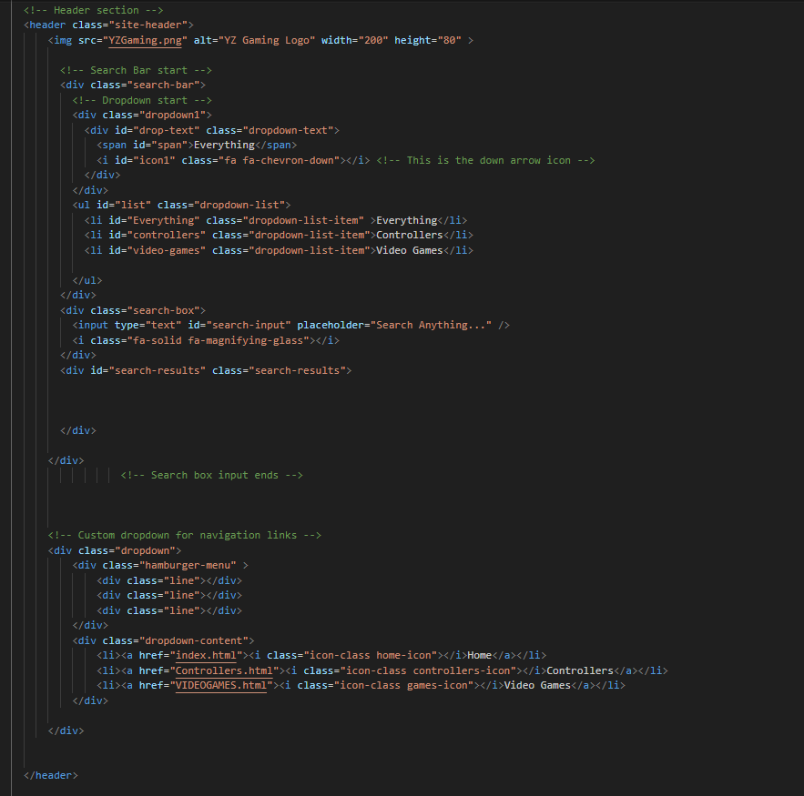

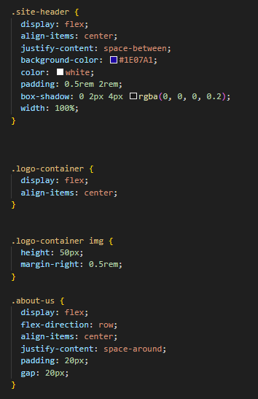

Header, logo

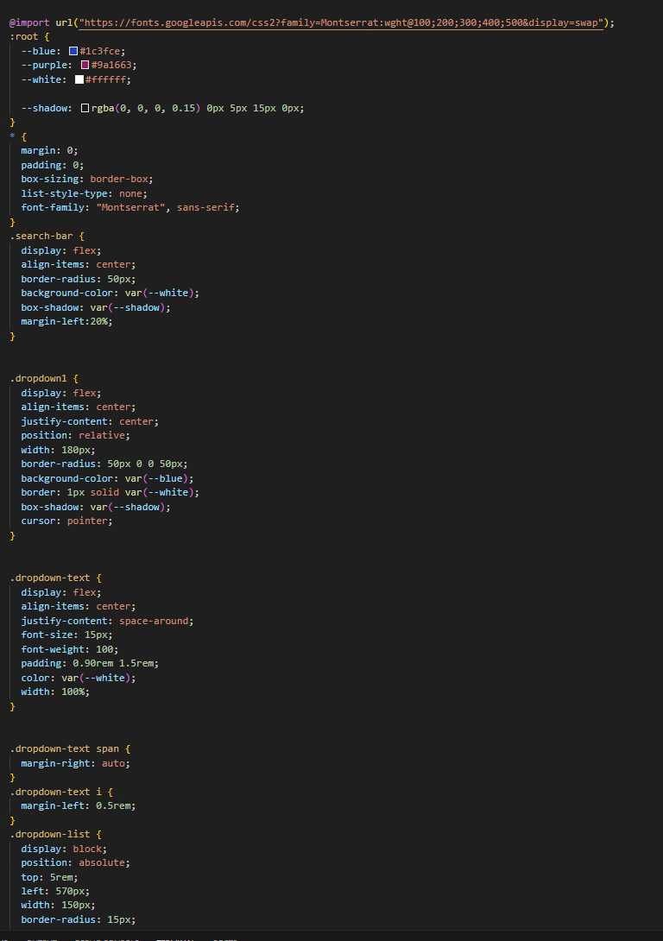

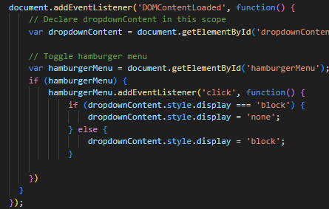



**Let's make sure that the search and filter feature works correctly**

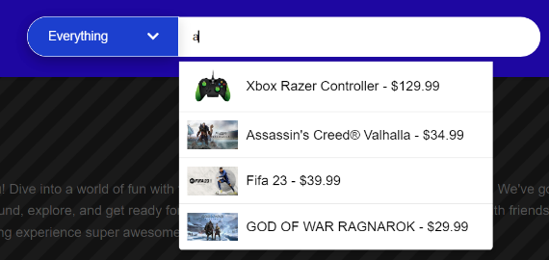



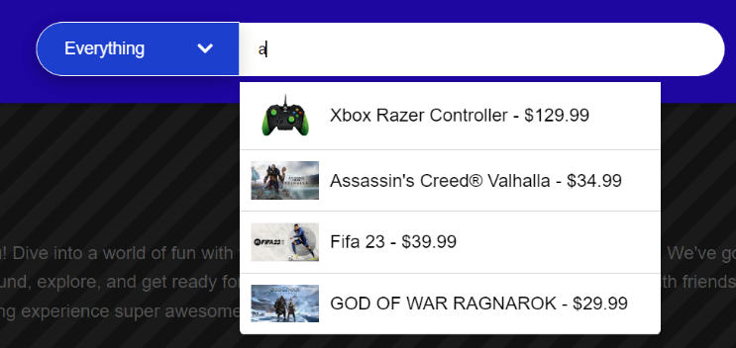

**Controller design, product details  
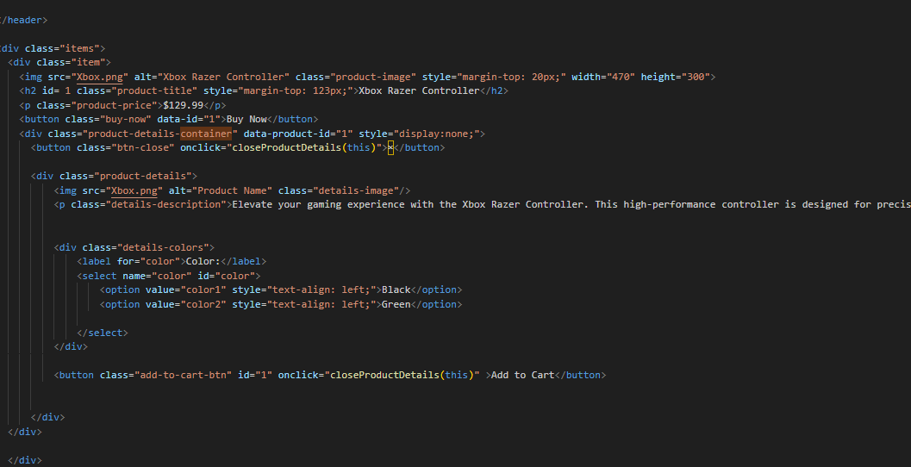**

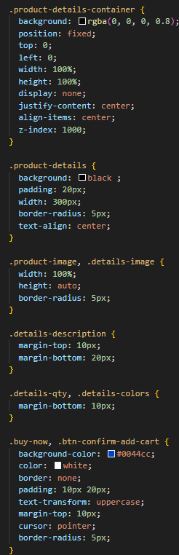

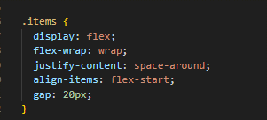

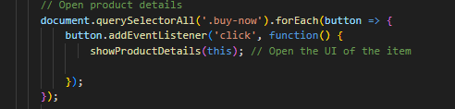

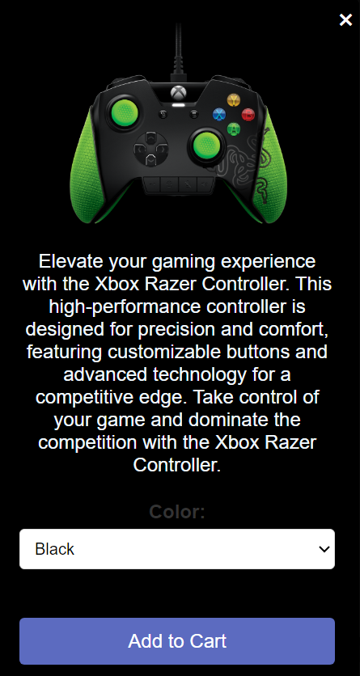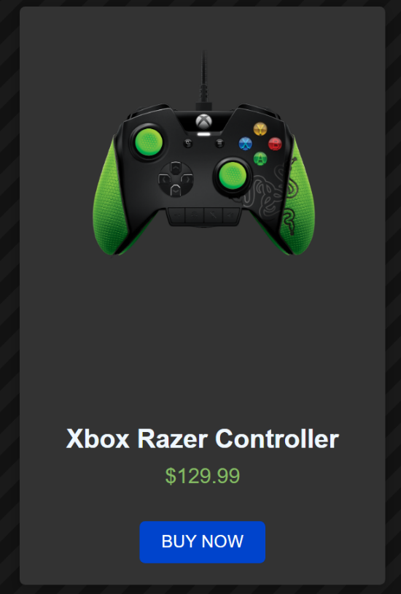

Footer,

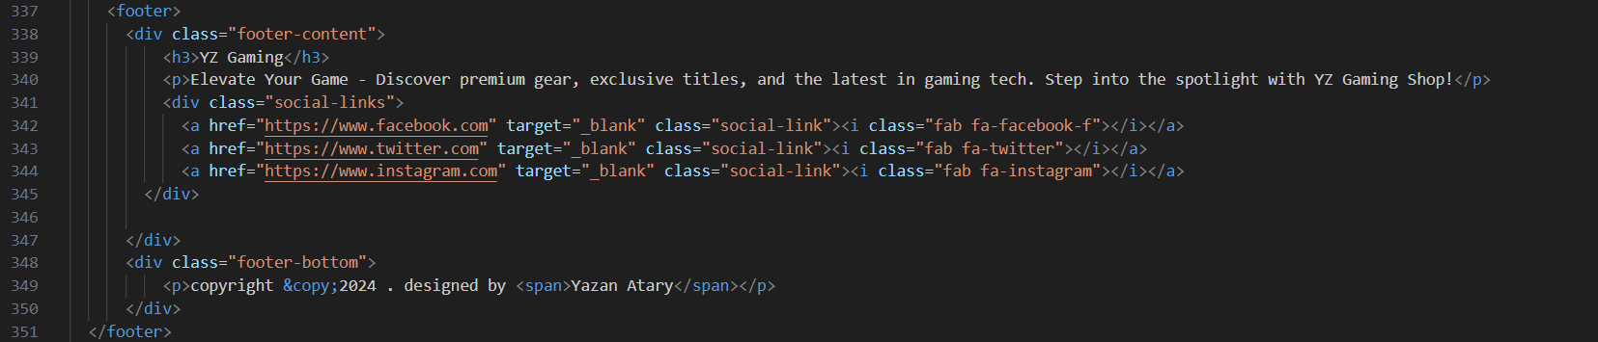

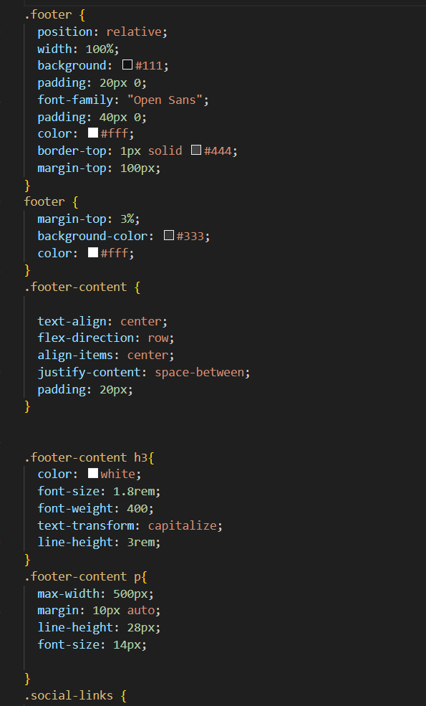



ADD Item Form

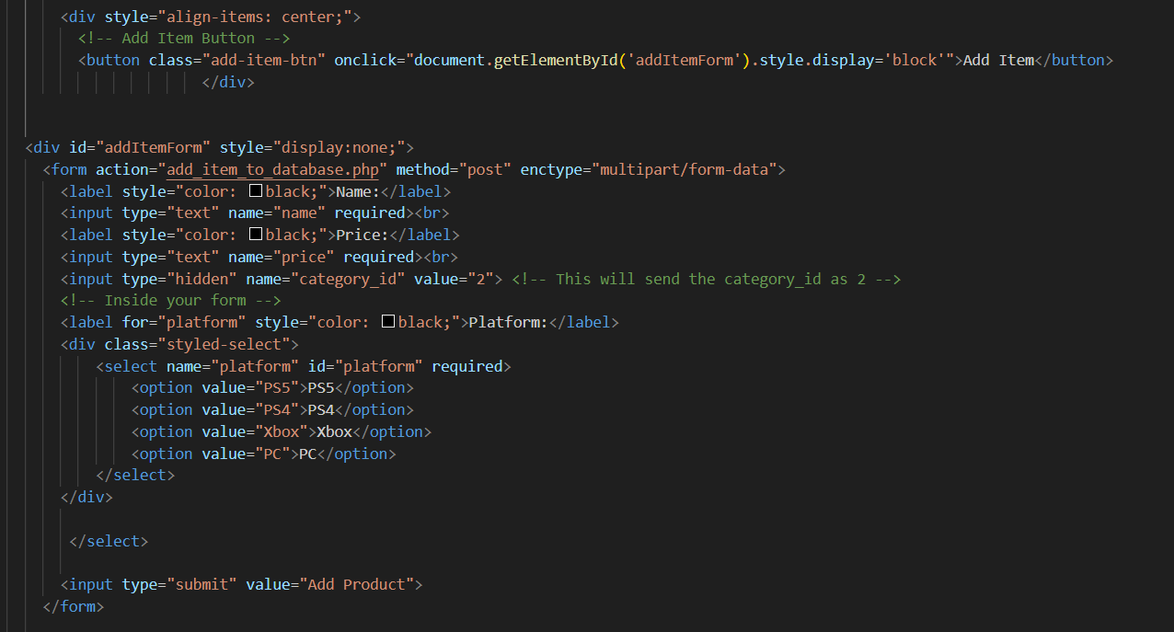

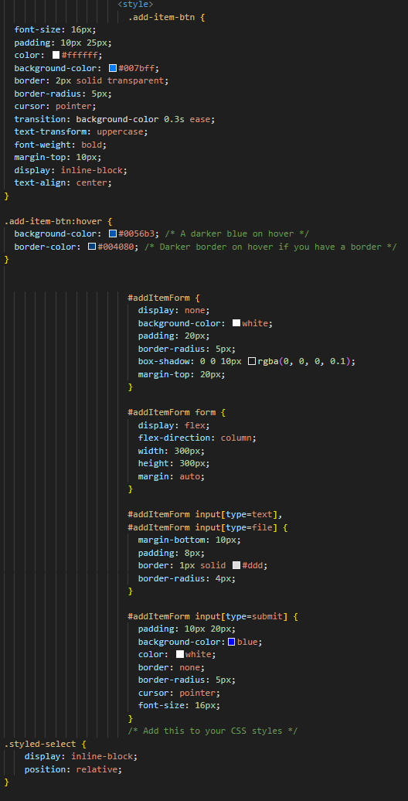

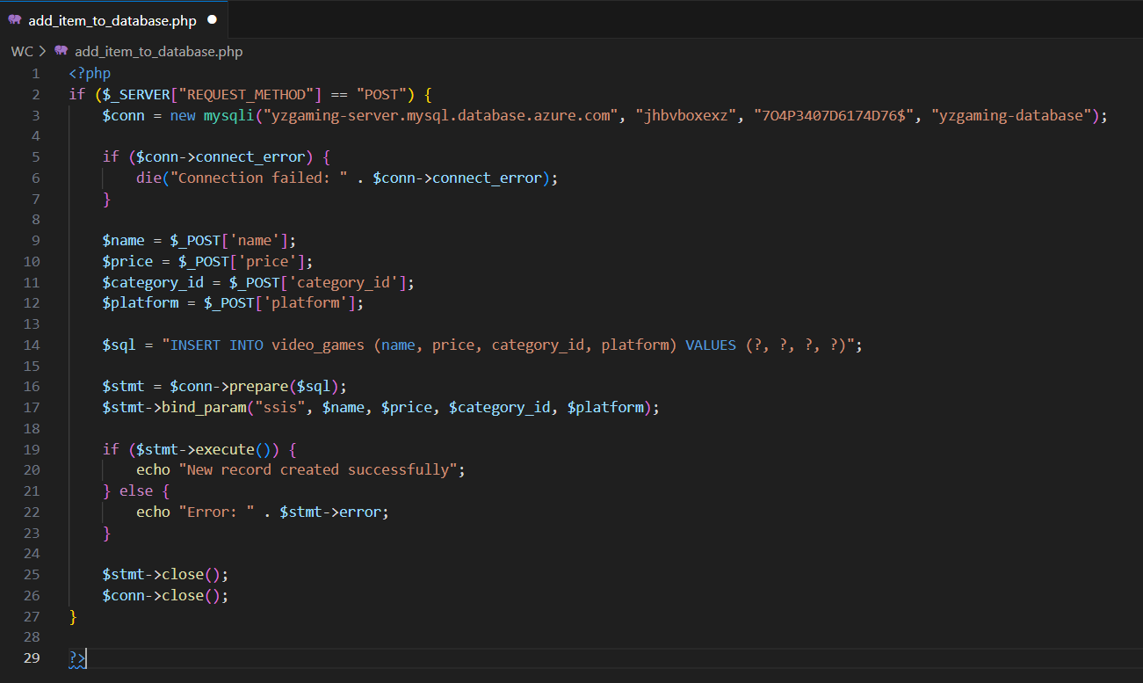

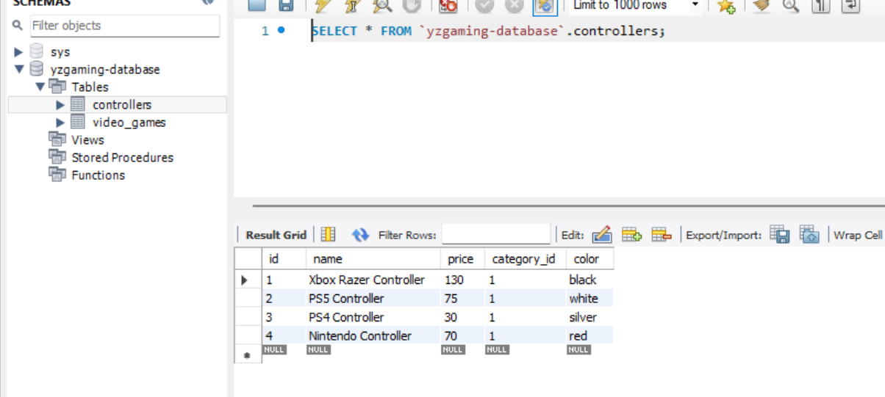

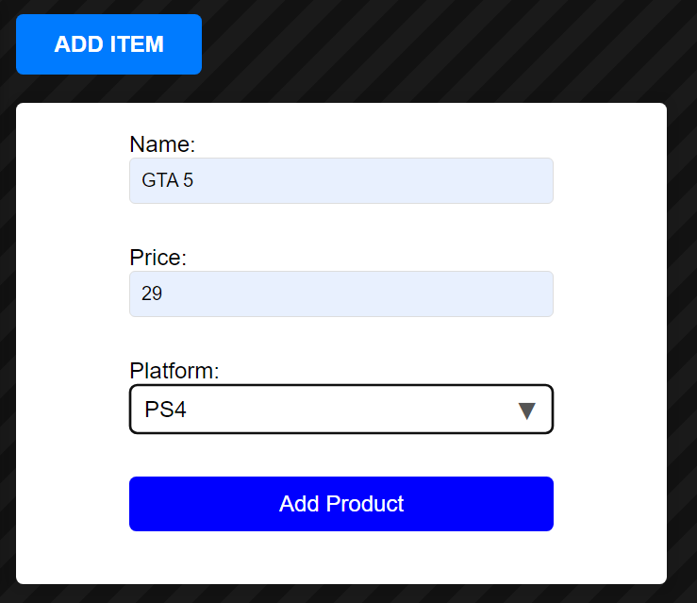



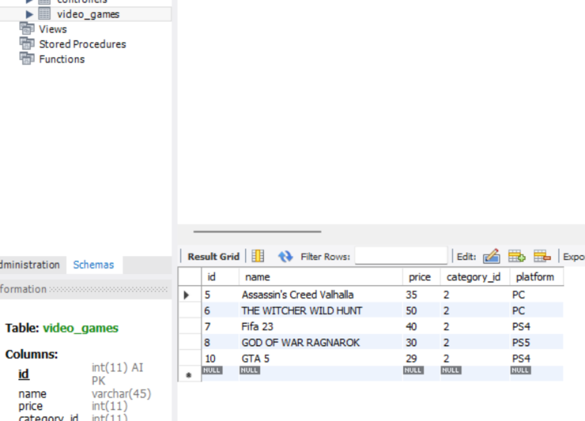

**Search and filter.**

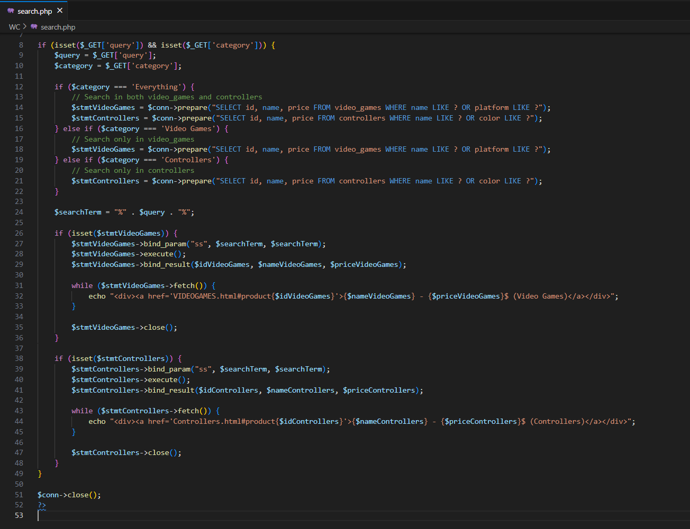

**Filter: Everything (controllers, video games)**



**Filter: Controllers**

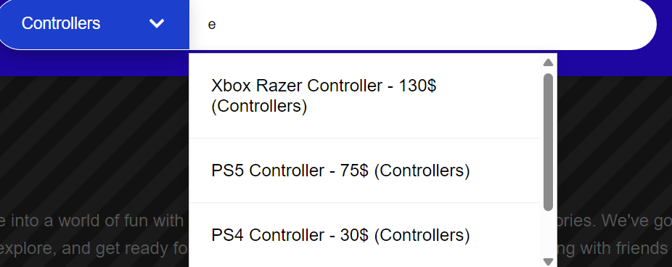

**Filter: Video Games**



**When the user clicks on the product, it takes them to the page where the product is located.**



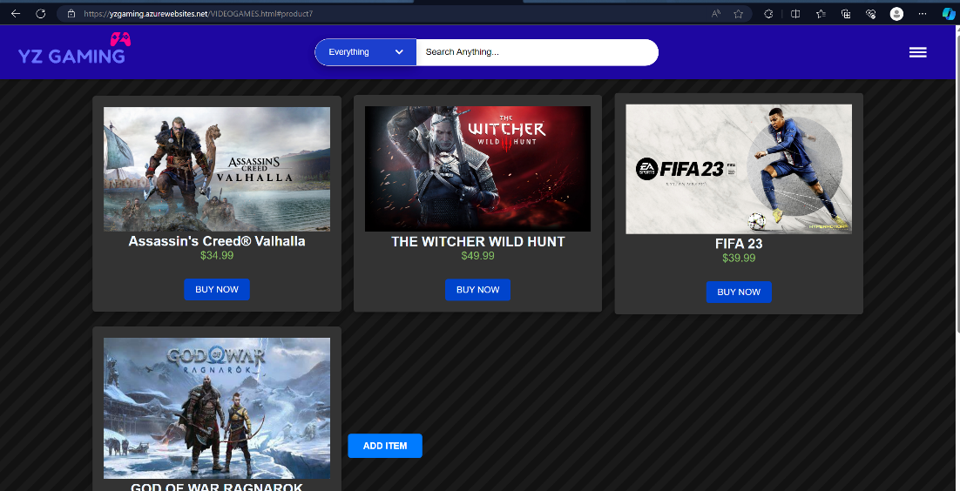

 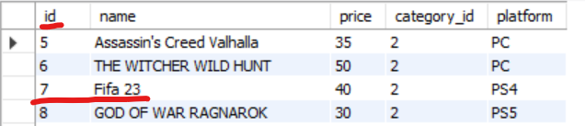

**9. Deploy the created website to the cloud infrastructure, and choose the right hosting services.**

**1 - All website files have been uploaded to github**

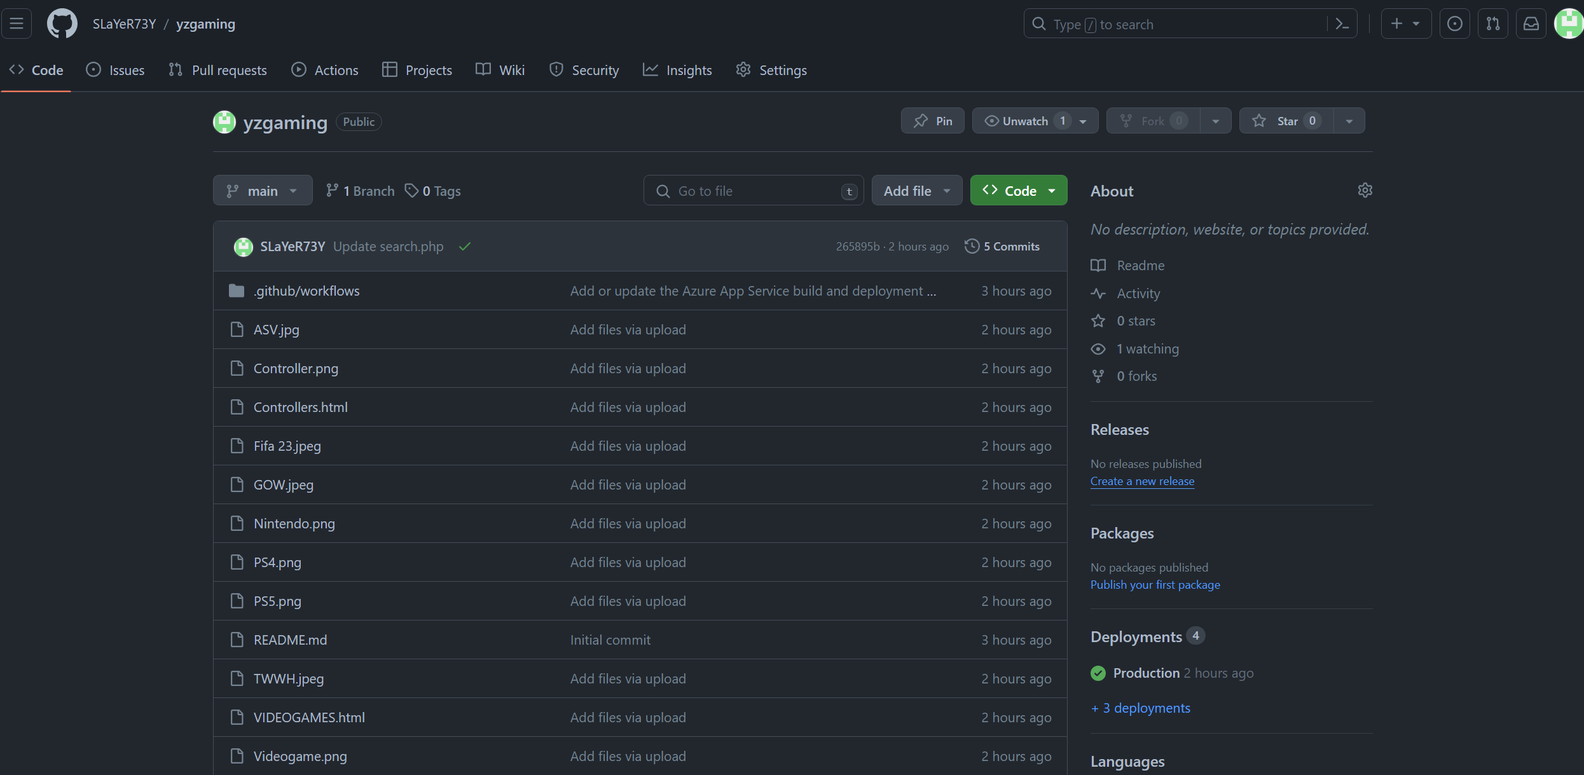

**2 – All private information in the website interface in Azure**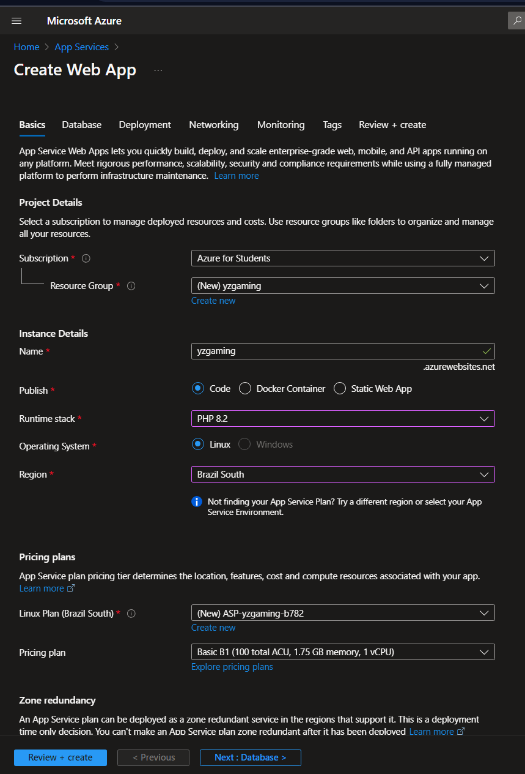

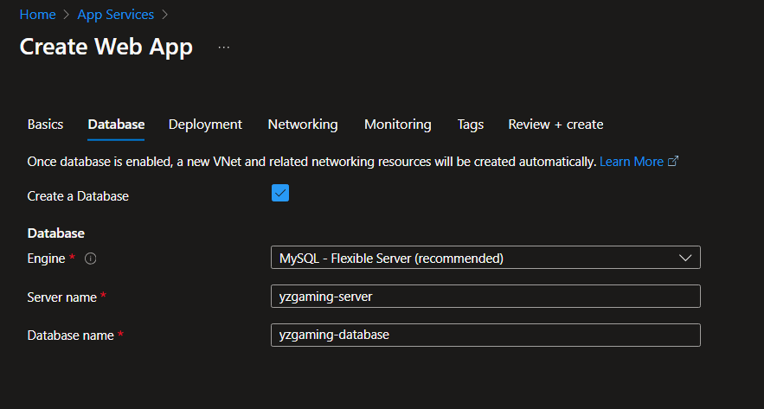

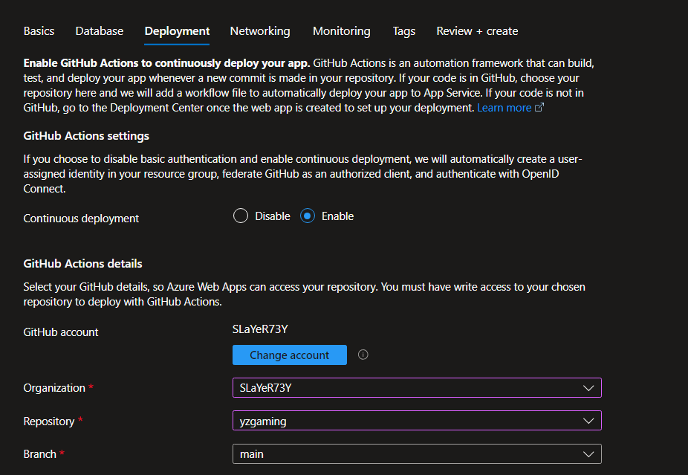

**3 – Creating a special database on the website to store information and products and take information from it (search feature from the database, and raise the user's products to the database)**

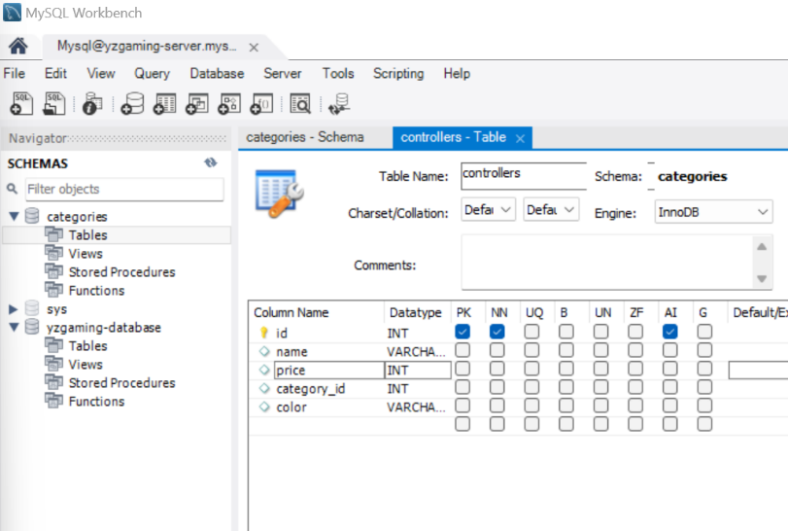

**4 – Linking the database in hosting**

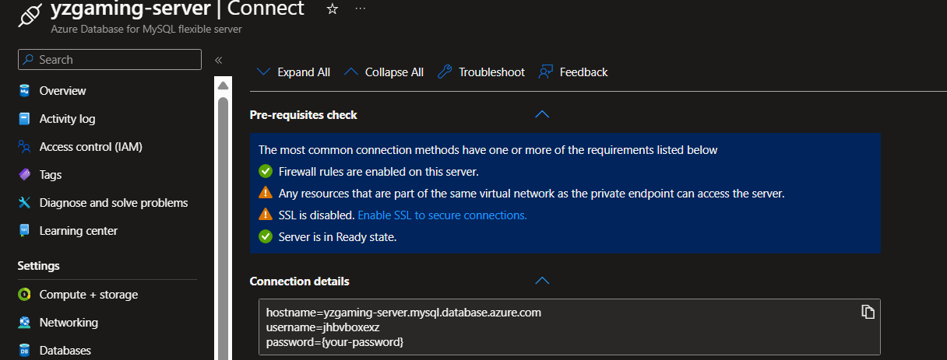

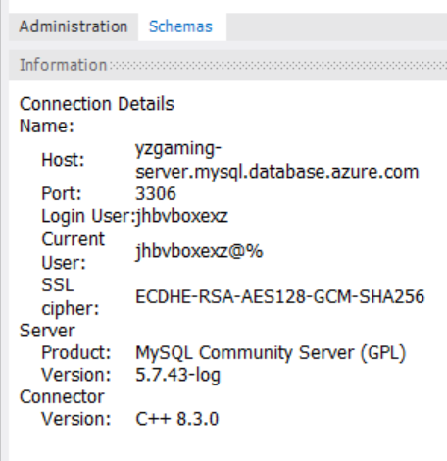 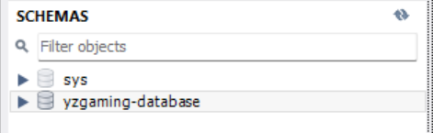

**To make sure that the user's product information is stored in the database correctly**

**Before storage:**

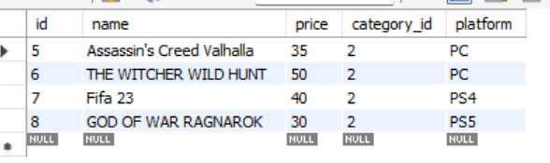

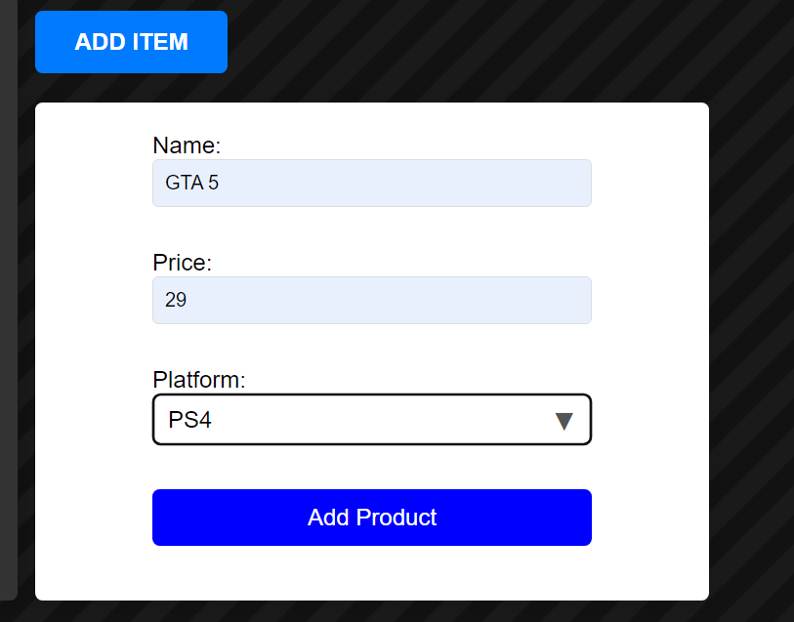



**After storage:**

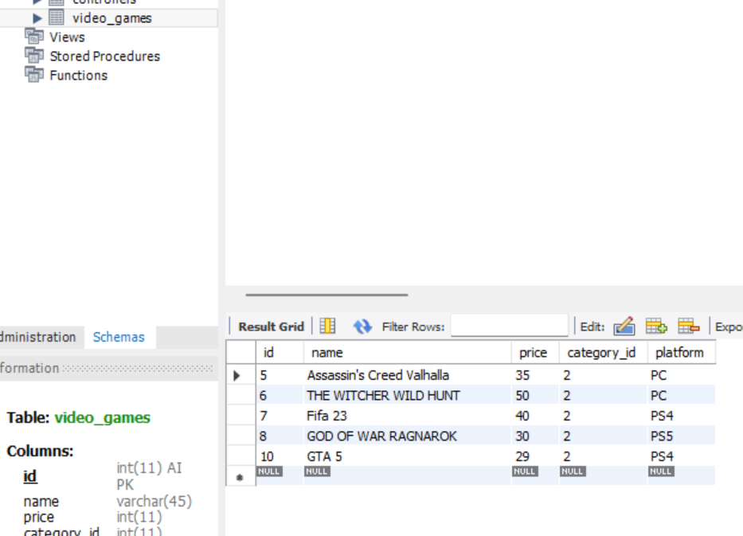



**10. Create a suitable test plan for the developed system and evaluate the results of your test plan. Do a thorough review of your multi-page website; use this assessment to explain areas of success and make justifiable recommendations for areas that require improvements.**

**TEST PLAN FOR YZ GAMING SITE:**

**Introduction:**

**Objective**: To verify the performance of the YZ GAMING website to ensure a seamless and secure experience for users.

**Scope:**

**Within range:**

User authentication.

Browse and select items (controllers, video games).

Shopping cart management.

Payment process and order confirmation.

Supervise the status of the application.

**Out of range:**

Advanced security tests with a focus on basic verification.

Performance testing under high traffic.

**Testing Strategy:**

**Manual testing:**

Test the basic functions of each item.

Check the ease of use of the interface.

Security testing to identify vulnerabilities.

**Automated Testing:**

Automated regression tests to check vital functions.

Integration testing for interactions with APIs.

**Test cases:**

**User authentication:**

Verify that the login was successful with the correct credentials.

Examine error messages for incorrect logon attempts.

**Browse items:**

Check if products appear based on categories.

Test search function and selection filters.

**Shopping Cart Management:**

Add and remove products and check the accuracy of the basket.

**Payment and order confirmation:**

Follow up the application process and ensure accurate calculations.

Test your shipping addresses and various payment methods.

**Payment Processing:**

Simulate successful and failed payment transactions.

Check the compatibility of different payment methods.

**Supervision of the status of the application:**

Confirm and verify the order details in the database.

**Test Environment:**

Browsers: Chrome, Firefox, Edge.

Devices: desktop, tablet, mobile.

Operating systems: Windows, Mac, iOS, Android.

**Test Schedule:**

The first stage: unit testing of individual components.

Second stage: integration testing to ensure smooth interaction between units.

Phase Three: Comprehensive System Testing.

Fourth stage: user acceptance test with real subscribers.

**Critical evaluation of results:**

**Success Criteria:**

All test cases pass successfully.

There are no critical security vulnerabilities.

Ease of use feedback is positive.

**Issues and challenges:**

Classification of problems based on their severity.

Immediately address challenges in user experience or system performance.

**Regression test:**

Perform regression testing after correcting problems.

**User Comments:**

Collect feedback from real users during the acceptance testing phase.

Evaluate feedback to identify areas for improvement.

**Continuous improvement:**

Document lessons learned and areas for improvement to improve the YZ GAMING website.

**Conclusion:**

Overall success was gained in the testing process, as it was ensured that the goals set for the YZ GAMING website were achieved. Future successes and improvements that can be implemented will be summarized in the following steps:

**Summarizing Success**

All functional testing cases have been successfully passed, demonstrating the effective performance of core functions.

Security: Underlying vulnerabilities have been successfully identified and addressed.

Usability: User feedback reflects an intuitive and user-friendly interface.

**Highlight improvements:**

**Improved performance:**

Facing some challenges in response speed during peak hours.

Implement advanced caching mechanisms and server upgrades to improve response times.

**Improved user authentication:**

Solved the difficult registration issue for some users.

Improved user authentication mechanisms for smoother login.

**Continuous improvements:**

Continuously monitor and analyze performance.

Expand features to improve the shopping experience.

Implement additional security measures to improve the overall security situation.

**Critical evaluation of results:**

**Success Criteria:**

Functional testing: All test cases pass successfully.

Security test: Vulnerabilities were successfully addressed.

Usability: User feedback reflects a user-friendly experience.

**Issues and challenges:**

Performance challenges: Response speed challenges were encountered during heavy traffic.

User authentication: A sign-in issue has been identified for some users.

**Regression test:**

After addressing the user authentication issue, a comprehensive regression test was performed to make sure that there were no new issues.

User Comments:

Positive comments: Users praise the user interface and ease of navigation.

Adverse feedback: Some users have reported performance issues during peak hours.

**Continuous improvement:**

Improve performance: Continue to improve response times.

User authentication: Continuous work to improve the sign-in experience.

Performance monitoring: Implement periodic performance monitoring.

Recommendations for improvement:

**Improved performance:**

Implement advanced caching mechanisms and server upgrades.

Analyze and optimize response times during peak hours.

User authentication improvements:

Solve difficult registration issues.

Develop user authentication mechanisms to improve the sign-in experience.

**Expand Features:**

Add new features to improve the shopping experience.

Provide personalized recommendations to users.

**Security improvements:**

Implement additional security measures, such as multi-factor authentication.

**PhotosTEST:**

**Search and filter.**



**Filter: Everything (controllers, video games)**



**Filter: Controllers**



**Filter: Video Games**



**When the user clicks on the product, it takes them to the page where the product is located.**





 

**To make sure that the user's product information is stored in the database correctly**

**Before storage:**







**After storage:**





**Azure Test**

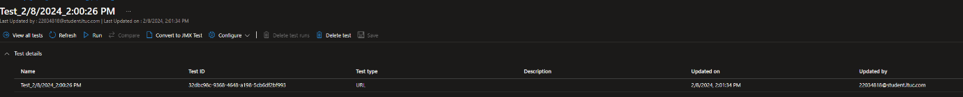

**During the test**

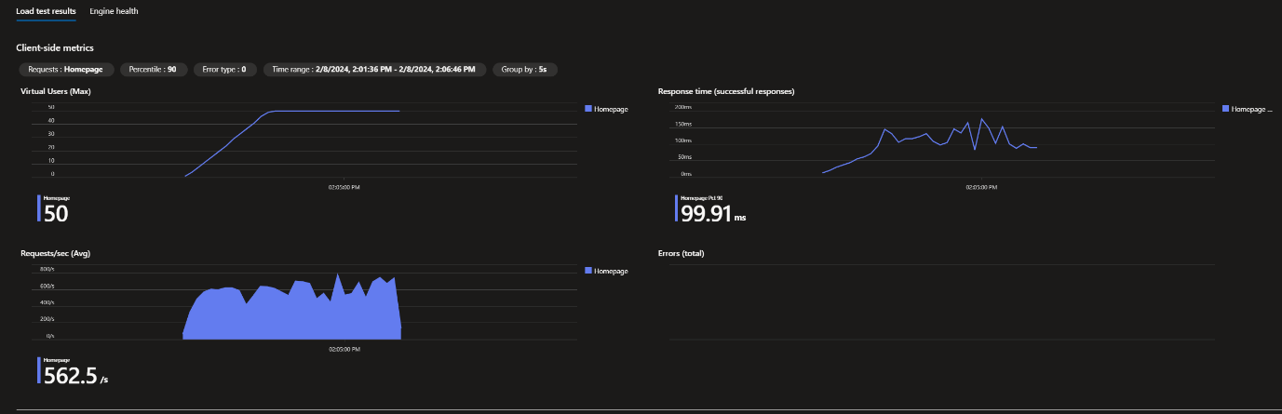

**After the test**

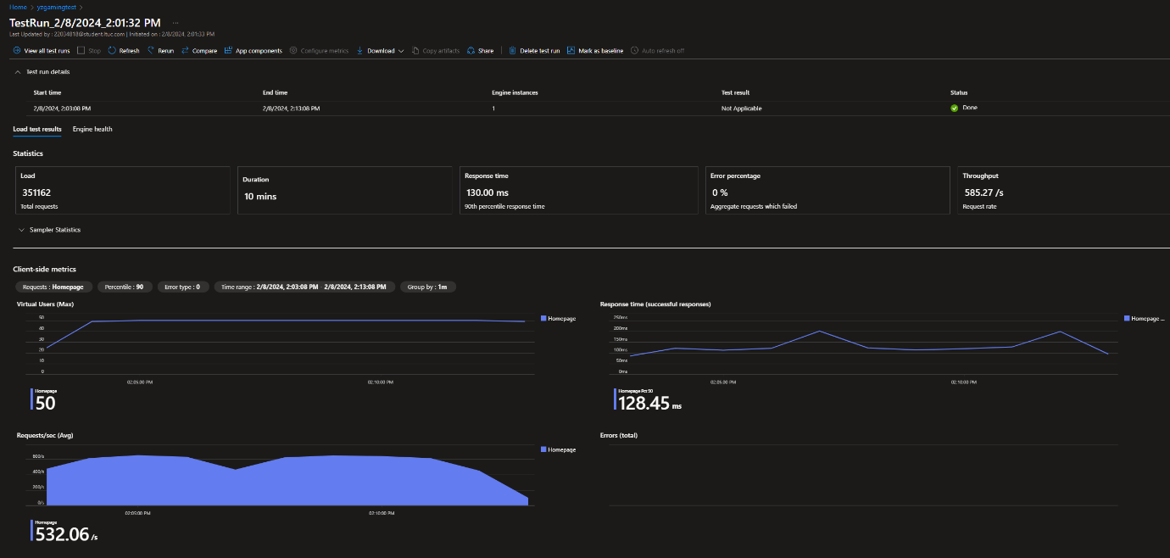

**By adopting these recommendations and working on areas that need improvement, the success of the site can be enhanced and the overall user experience improved.**

11. Compare the multi-page website developed with the design document, and then, justify any modifications made based on the test results.

**Analysis of variance and rationalization of adjustments in the YZ GAMING website:**

**Front end frames:**

**Design document:**  Suggest React or Angular.

Implementation: Visual Studio with HTML , CSS, andJavaScript.

**Back-end frameworks and databases:**

Design document: Node.js or Django and MongoDB or PostgreSQL are suggested.

Implementation: Visual Studio with PHP and MySQL (on AWS using XAMPP).

**Search Engine:**

Design document: Prefer Elasticsearch or a similar search engine.

التنفيذ: Microsoft Edge.

**Cloud Hosting:**

Design document: AWS or Azure is recommended.

Implementation: Deployed to Azure.

**UI/UX design tools:**

Implementation: Use Visual Studio for development.

**Adjustments based on test results:**

Based on the test results, no adjustments were made as a result of the reservation shown by the last observation. Limited experience was used to create the site, and the techniques used were not changed based on the results. Feedback and recommendations for site improvement may be considered in the future, and it may be useful to consider adopting the techniques recommended in the design document to enjoy the full benefits available.

**12. Evaluate the design and development process for the design document, focusing on any technical hurdles encountered and explaining the strategies used to overcome them.**

**In the process of designing and developing the YZ GAMING website, the focus was on making the experience enjoyable and smooth for the players. To improve this process, the design document was reviewed and the development evaluation was evaluated with a focus on some key points:**

**Design Process Evaluation:**

**1. Clear identification of players' needs:**

The design document clearly outlines the expectations and needs of players, making it easier for the development team to effectively meet those needs. Paying attention to the requirements of the target audience enhances the end user experience.

**2. Effective communication between design and development teams:**

A good understanding of system requirements and continuous interaction between design and development teams achieves better compatibility and contributes to improving the quality of the final product. Coordination and constant communication avoids discrepancies in interpretations and reduces the likelihood of errors.

**Technical challenges:**

**1. Diversity of technologies used:**

**Improving technical harmony:**

This includes a shift towards the use of programming languages and technologies shared by design and development teams. It creates better harmony and reduces excessive complexity.

**٢**

**. Response times:**

**Improve site performance:**

This includes improving response times through the use of system optimization technologies, and using caching mechanisms to reduce the effects of delays and improve the user experience.

**Strategies to overcome obstacles:**

**1. Standardization of technologies:**

**Standardization of programming languages:**

The strategy entails standardizing the programming languages used in design and development. This improves the interaction between the two teams and facilitates maintenance and updates.

**2. Improve system performance:**

**Apply performance improvements:**

It consists in implementing continuous improvements in system performance, including continuous monitoring and improvements that improve site responsiveness.

Future improvements:

**1. Innovation in User Experience:**

**Expand gameplay features:**

Introducing more innovative and interactive features to players to improve their experience and make the site more attractive.

**2. Advanced Technology:**

**Explore new technologies:**

Employing advanced technology such as virtual reality or augmentation techniques to expand the player experience.

**Review of strengths:**

**1. Positive impression of the user experience:**

**Stay focused:**

Continuing to enhance and improve the user experience will maintain a positive impression and contribute to attracting more players.

**٢**

**. Work harmony between teams:**

**Achieving better harmony:**

Ensure continuous communication and effective interaction between the design and development teams to achieve better harmony in all aspects of the project.

**With the continuity of these efforts and the implementation of continuous improvement strategies, a distinctive player experience can be achieved and the success of the YZ GAMING website in the gaming market can be ensured.**

**13. The quality assurance process is expected to detect design issues and development errors during product user interface (UI) testing and user experience (UX) measurement.Evaluate the quality assurance (QA) process and see how it is implemented during the design and development phases.**

**1. Design Stage:**

**Define UI requirements:**

Before the beginning of website development, QA is involved in analyzing system requirements and understanding the needs of potential users. This is done in collaboration with the design team to ensure that the user interface meets the expectations and preferences of users.

**Design evaluation and follow-up communication:**

QA participates in evaluating design schemes and ensuring their compliance with requirements and directives. Emphasizes continuous communication between the design and development teams to improve processes and ensure an effective response to any modifications.

**2. Development Phase:**

**Unit Tests and Integration:**

Before moving on to larger stages, QA performs tests of software modules to verify that each part is working properly. In addition, the integrity of different elements is tested to make sure that they interact smoothly.

**Performance and Response Testing:**

QA participates in a site's performance testing to ensure its ability to handle heavy traffic. Response times and site performance are analyzed to ensure that it meets needs during peak periods.

**3. User Experience Assessment (UX):**

**User Experience Testing:**

QA organizes user tests to get live feedback on user experience. These feedback are analyzed to identify more areas that can be improved in the user interface.

**Error report analysis:**

Reports on errors and problems detected are submitted to the development team. QA is involved in analyzing these reports to understand the causes and ensure that they are effectively corrected.

**4. Final stage:**

**Continuous Quality Assurance:**

Over time, QA continues to monitor performance and quality to ensure that the site continues to meet expectations. Sometimes it releases small updates to improve on specific matters.

**Conclusion:**

QA plays a crucial role in maintaining and continuously improving product quality. It requires continuous interaction with design and development teams, the use of advanced testing techniques, and a quick response to improve the overall experience of YZ GAMING users and ensure their satisfaction.

**Choosing Azure for YZ Gaming hosting:**

**Based on available data and analysis of options, hosting the YZ Gaming site on Azure appears to be a balanced choice that combines technical capability and ease of use. Let us explore the important aspects in more detail:**

**Ease of use:**

The Azure interface has a simplified design and ease of interaction. Providing an effective control panel makes managing the site simple even for new users. Developers and administrators can easily navigate to configure services and manage resources.

**Effective database:**

Azure DBMS enables efficient use of YZ Gaming data. Users can easily manage and access data consistently. This includes the ability to execute efficient queries and improve database performance.

**Sustainable Expansion:**

Providing scalable hosting models in Azure means that the site can adapt to increasing data volume and traffic effectively. Auto-scaling features allow resources to be allocated automatically to ensure continuity of service.

**Efficiency and Responsiveness:**

Azure enables efficient site performance, with fast page load times and fast response to requests. Analysis of performance data shows that the site benefits from an advanced hosting environment that contributes to improving the user experience.

**Core Azure features :**

Azure appears to provide a wide range of useful core features, including web services and databases. These features support the implementation of location requirements effectively.

**Security and stability:**

Security services in Azure include support for SSL and advanced protection systems. Azure also has high stability, offering continuous uptime with limited downtime.

**Data routing:**

Azure Data Routing provides an improvement in site security and ensures that data remains available in a secure manner. Leveraging this feature shows enhanced protection and reliability.

**Conclusion:**

Based on these points, choosing Azure to host YZ Gaming is a calculated decision. The balance between ease of use and technical capability ofAzure allows for improved user experience and reliable and efficient site performance.

**14. Explores the suitability of the hosting service chosen for the proposed Caveni Digital Solutions website, using aggregated metrics data, to ensure its compliance with user requirements.**

**Azure hosting for YZ Gaming was selected based on available data, which provides an appropriate balance between technical attributes and ease of use. This choice shows advantages and strengths that can be focused on:**

**Scalability:**

The current solution demonstrates flexible expansion capacity to accommodate increased traffic.

The service infrastructure allows the site to be expanded without significantly impacting performance.

**Performance:**

Deliver fast and reliable performance that meets user expectations.

Appropriate page load times and effective response to the site.

**Uptime and Reliability:**

Provide high uptime with limited downtime.

Achieve continuous site access without significant impact of breakdowns.

**Security:**

Support for strong security features including SSL and firewalls.

Comply with industry standards in data protection and user privacy.

**Cost Effectiveness:**

Strike a good balance between cost and benefits.

A reasonable budget allows maintaining good performance of the site.

**Support and customer service:**

Provide a responsive and knowledgeable support service.

Strong support to address issues instantly and improve user experience.

**Compliance and Regulations:**

Adhere to relevant compliance standards and data protection.

Provide a legally and technically reliable environment.

**Backup and Recovery:**

Provide powerful backup options for data protection.

Easy data recovery in case of loss or malfunction in the system.

**User Notes:**

Listen to user feedback about accessibility and performance.

Respond to users' problems effectively to improve user experience.

**User Experience:**

User-friendly and responsive interface design to improve user experience.

Ensure smooth interaction with the site and easy access to content.

**Future improvements:**

Provide scaling capabilities to integrate new features in the future.

Flexibility for subsequent design and performance improvements.

**Communication with the technical team:**

Having effective means of communicating with the technical support team.

Provide documents and resources to help developers when needed.

**Use of modern technologies:**

Continuous updating of the technology used in hosting.

Use the latest technology to improve the performance and security of the site.

15. Test analysis data on the web, by conducting a comprehensive review of the success of the proposed multi-page site of the Caveni Digital Solutions store, and leverage this evaluation to illustrate what works while providing justified recommendations for areas that need improvement.

To assess the success of the Caveni Digital Solutions multi-page site, analysis data testing was performed using the JMeter tool. The results showed many positive points and areas that need improvement, which helps in improving the user experience and overall performance of the site.

**Strengths:**

**System Performance:**

The test results showed high stability of site performance even in conditions of high load.

Response times were short, indicating the effectiveness of the server system and infrastructure.

**Fast Loading:**

Fast page load times have been achieved, contributing to a positive user experience.

Use advanced techniques to compress content and enhance images.

**User Response:**

Quick response to users' requests is an important strength.

Use repetitive content caching techniques to improve the time required for pages to load.

**Areas for improvement:**

**Improved security:**

Improve security measures and provide more details on measures taken to protect data.

**Improved error communication:**

Improved error messages to provide clear guidance to users if errors occur.

**Improved user experience:**

Think about improving the user interface based on user feedback and use user analysis tools to better understand their needs.

**Recommendations:**

**Intensifying security tests:**

Increase security testing efforts to ensure better data protection.

**Improved error communication:**

Improve error messages and provide accurate guidance for users to deal with problems.

**Use user analysis:**

Use user analysis tools to understand user behavior and optimize interface design accordingly.

**PhotosTEST:**

**Test**



**During the test**



**After the test**



**By adopting these recommendations and working on areas that need improvement, the success of the site can be enhanced and the overall user experience improved.**

**References:**

Ellman, J., Lee, N., & Jin, N. (2018). Cloud computing deployment: a cost-modelling case-study. Wireless Networks, 29(3), 1069-1076.

Sultan, S., Ahmad, I., & Dimitriou, T. (2019). Container security: issues, challenges, and the road ahead. Ieee Access, 7, 52976-52996.

Opara-Martins, J., Sahandi, R., & Tian, F. (2016). Critical analysis of vendor lock-in and its impact on cloud computing migration: a business perspective. Journal of Cloud Computing Advances Systems and Applications, 5(1).

Tafti, A., Rohani, F., & Moghaddasifar, M. (2012). Towards a scalable g2g framework for customs information system through n-tier architecture.

Huebscher, M. and McCann, J. (2008). A survey of autonomic computing—degrees, models, and applications. Acm Computing Surveys, 40(3), 1-28.

Zhang, Q., Li, S., Li, Z., Xing, Y., Yang, Z., & Dai, Y. (2015). Charm: a cost-efficient multi-cloud data hosting scheme with high availability. Ieee Transactions on Cloud Computing, 3(3), 372-386.

Lim, W. M. and Ting, D. H. (2012). E-shopping: an analysis of the technology acceptance model. Modern Applied Science, 6(4).

Tripathi, V., Chattopadhyaya, S., Bhadauria, A., Sharma, S., Li, C., Pimenov, D. Y., … & Gautam, G. D. (2021). An agile system to enhance productivity through a modified value stream mapping approach in industry 4.0: a novel approach. Sustainability, 13(21), 11997

Patil, R. (2020). Secure scalable attribute based access control (ss-abac) in cloud environment. International Journal of Advanced Trends in Computer Science and Engineering, 9(4), 6737-6741.

Tripathi, V., Saraswat, S., & Gautam, G. D. (2021). Development of a systematic framework to optimize the production process in shop floor management. Lecture Notes in Mechanical Engineering, 57-66.

Ahmad, A. A. and András, P. (2019). Scalability analysis comparisons of cloud-based software services. Journal of Cloud Computing, 8(1).

Ichanska, N., Podoshvelev, Y., Smitskiy, O., & Rybachenko, K. (2018). A quality selection of software to build a service of electronic equipment sales. control, navigation and communication systems. Collection of scientific papers, 3(49), 111-115.